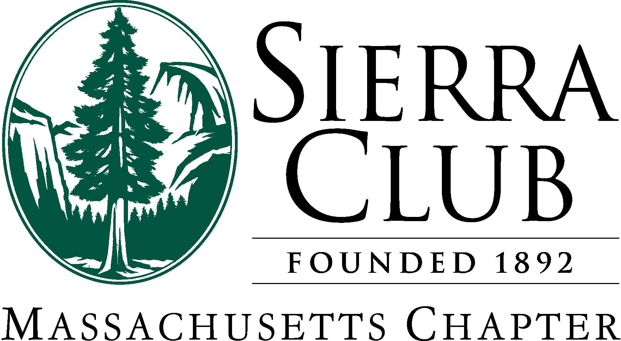
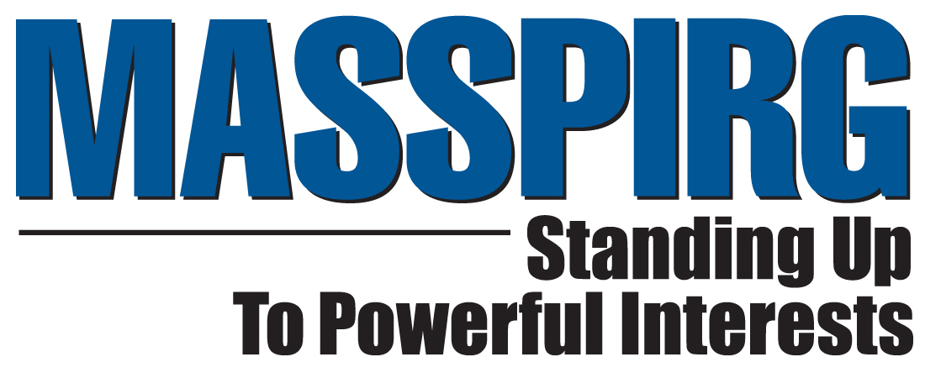

The Bottle Bill Update

An Act to Improve Recycling Rates in the Commonwealth

H3515/S1480, Rep. Alice Wolf, Sen. Cynthia Creem

The Bottle Bill Update would increase recycling rates by adding bottled water, sports drinks, iced tea, and other beverages to the current deposit system. Since its inception, more than 30 billion containers have been redeemed under the Massachusetts bottle bill, contributing to a healthier environment, cleaner and safer communities, and a stronger economy. But as consumers’ tastes change, the bottle bill must be updated to keep up with our times.
Increases Recycling Rates: Approximately 80% of bottle-bill-covered beverages are redeemed/recycled. Only 22% of NON-covered beverages are recycled.
Complements Curbside Recycling: Curbside is very effective for beverages consumed at home. But the majority of single-serving containers are consumed on-the-go, out of curbside’s reach.
Endorsed by MMA, Metro Mayors Coalition, Over 130 Municipalities – and Just About Every Environmental Group in the State: Enacting the update would save our cities and towns significant amounts, from lowering disposal costs, litter collection costs, and storm drain cleaning, which are frequently blocked by littered containers.
Decreases Landfill Use: The state is running out of landfill space. The 1 billion containers that we send to landfills every year would fill Fenway Park to overflowing.
Saves Energy, Saves Oil: Most of the containers under the update are made of PET, 99% of which is petroleum. Recycled PET is badly needed for textiles. Had these bottles been recycled, we would have saved the energy equivalent of about 48,000 barrels of oil.
Strong Public Support: The public is very supportive of the bottle bill, seeing the positive effect that it’s had on the environment.
Producer Responsibility: Bearing the cost of a product's waste should be the responsibility of beverage producers and consumers, not taxpayers and communities. The bottle bill is a model for this kind of sustainable financing.
Creates Green Jobs: Gains in employment have been shown in nearly every state that updates their deposit system. Many of these jobs come in the recycling sector, which now produces important – and sustainable – raw materials to be used in manufacturing.
Keeps Current With Consumer Habits: The original bottle bill was never meant to be non-reactive to consumer trends. Now that 1/3 of our containers are not covered by the 27-year old law, we need to update it.
Revenue Positive for the State: Unclaimed deposits are maintained by the state. The cost of updating the bottle will not require any funding.
Supports the Redemption Centers: The bill includes provisions to increase the handling fee (not paid by the state). These small, often family-owned business have not had an increase in handling fees in 18 years. They are currently experiencing huge increases in operating costs; many of them have been forced to close.
Provides Relief for Small Stores: The update allows small stores to opt out of taking returns if there’s a nearby redemption center.
No Additional Costs for Supermarkets: Almost all large supermarkets have more than enough capacity in their “reverse vending machines” to accept the increase in containers. Neither additional machines nor floorspace would be required.
Rev. 3/24/2010

